|  |
| --- |
| Department of Software Engineering  Mehran University of Engineering and Technology, Jamshoro |

|  |  |  |  |
| --- | --- | --- | --- |
| Course: SWE – Artificial intelligence concepts and techniques | | | |
| Instructor | Eman Shahid | **Practical/Lab No.** | 07 |
| Date |  | **CLOs** | 03 |
| Signature |  | **Assessment Score** |  |

|  |  |
| --- | --- |
| Topic | Learning to use python speech recognition tool |
| Objectives |  |

|  |
| --- |
| Lab Discussion: Theoretical concepts and Procedural steps |

**Google Speech API**

Speech Recognition is an important feature in several applications used such as home automation, artificial intelligence, etc. This is useful as it can be used on microcontrollers with the help of an external microphone.

**Installation**

* **Python Speech Recognition module:** 
  + pip install SpeechRecognition
* **PyAudio (for microphone users)**
  + pip install pyaudio

**Recognize speech input from microphone**

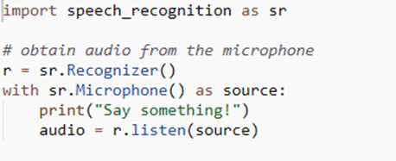

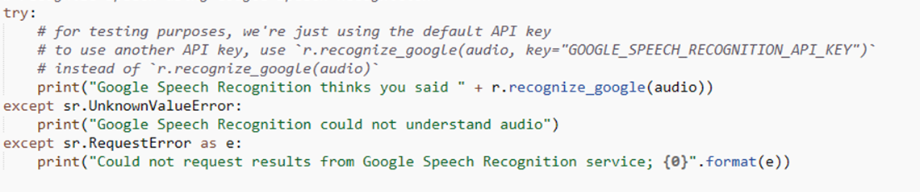

**Output:**

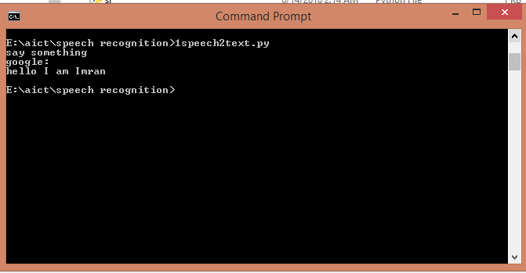

**Chrome search using google speech recognition**

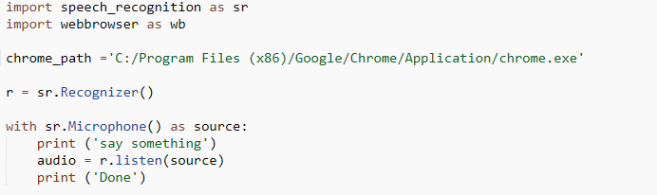

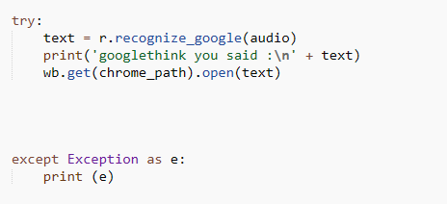

**Output**

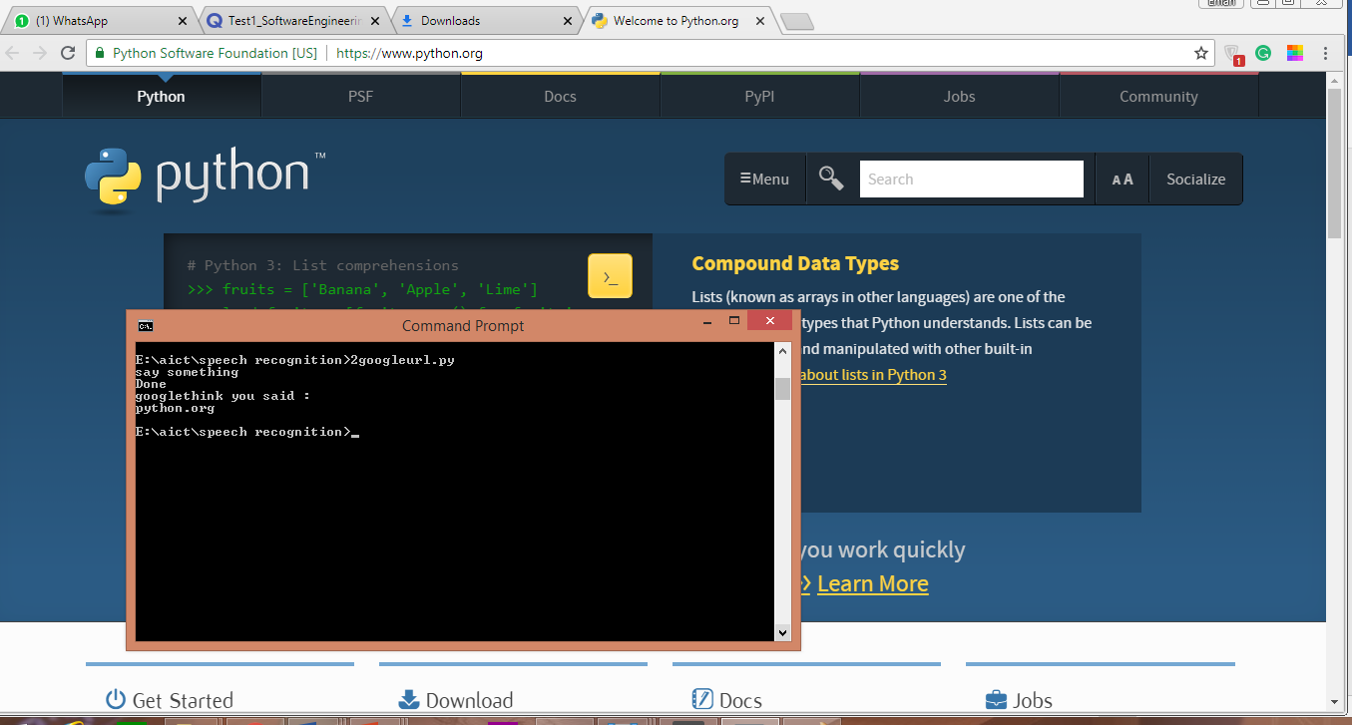

|  |
| --- |
| Class Tasks |
| Submission Date: 31/7/2018 |

1. Execute all the programs provided in the handouts.

|  |
| --- |
| Lab Tasks |
| Submission Date: 31/7/2018 |

1. Record your own voice audio at runtime and save it in the following formats(raw,wav,aiff,flac).
2. Write a program to read audio file and show the recorded data on the console.